DAY 4 — IMAGE GENERATION, CANVA AI AND TOOL SELECTION

AI Image Generation

- Create a professional promotional image of young travellers inside a modern airport terminal. Use blue and white brand colours, natural lighting and a landscape layout. Do not include airline logos or text.



- Create a professional promotional image for airline advertisements. Use multi colour brand colours, natural lighting, ads should look attractive to customer and a landscape layout. Do not include airline logos or text.



- Create a professional destination-marketing photograph showing young international travellers exploring a beautiful European city, historic architecture, outdoor café, luggage, natural daylight, realistic photography, premium travel advertising style, vibrant but natural colours, landscape composition, no logos, no text.



- Create a professional social-media campaign photograph showing young travellers enjoying a modern international airport terminal, large glass windows, aircraft visible outside, digital information displays, cafés and comfortable seating, natural daylight, realistic photography, premium aviation advertising style, vibrant but natural colours, landscape composition, no airline logos, no text.



- Create a professional aviation training-material visual with a fresh, modern colour theme that is different from traditional blue-and-white airline branding. Use a sophisticated combination of purple, teal, coral, orange, and soft cream, with clean white space and subtle gradients. Show a modern airport training environment with diverse airport employees, including ground staff, passenger-service agents, security personnel, and operations staff. Include visual elements representing passenger service, airport safety, security awareness, emergency procedures, sustainability, teamwork, and professional communication. Use realistic high-quality photography combined with modern corporate infographic design, clean icons, rounded shapes, organized information panels, premium educational presentation style, landscape composition, suitable for aviation employee training, classroom presentations, workshops, and training manuals. No airline logos, no brand names, no misleading safety instructions, and minimal readable text.

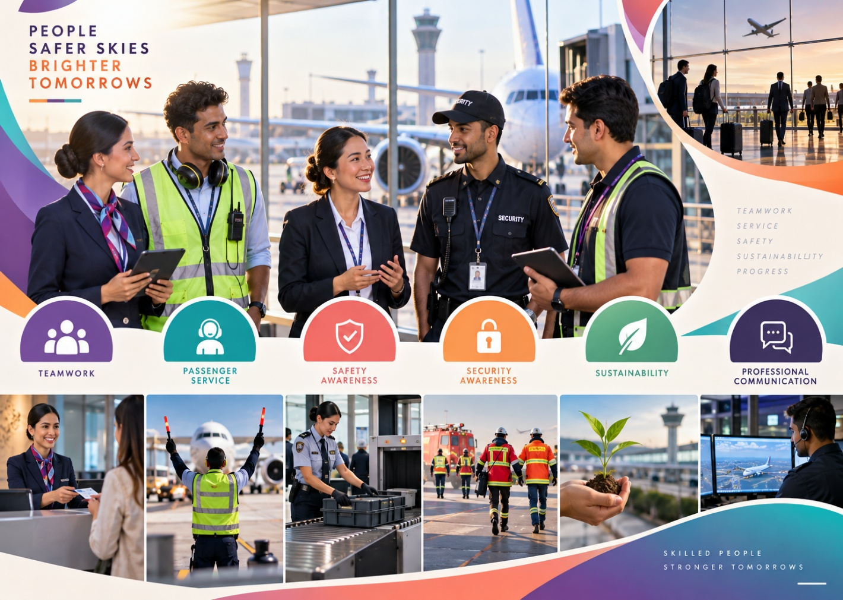

Create a professional aviation-themed presentation background for a PowerPoint slide. Use a modern purple, teal, coral, and soft cream colour palette instead of traditional blue-and-white airline colours. Show a sleek modern airport terminal with large glass windows, subtle aircraft silhouettes, runway lights, airport architecture, and abstract aviation-inspired shapes. Keep the design minimal, elegant, and uncluttered, with most of the left or centre area clean and empty for adding presentation text. Use soft gradients, subtle geometric curves, premium corporate design, realistic but slightly stylized photography, sophisticated lighting, landscape 16:9 composition, high resolution. No logos, no airline brands, no readable text, no people dominating the frame. Suitable for BBA Aviation presentations, airport-management projects, business presentations, and academic slides.


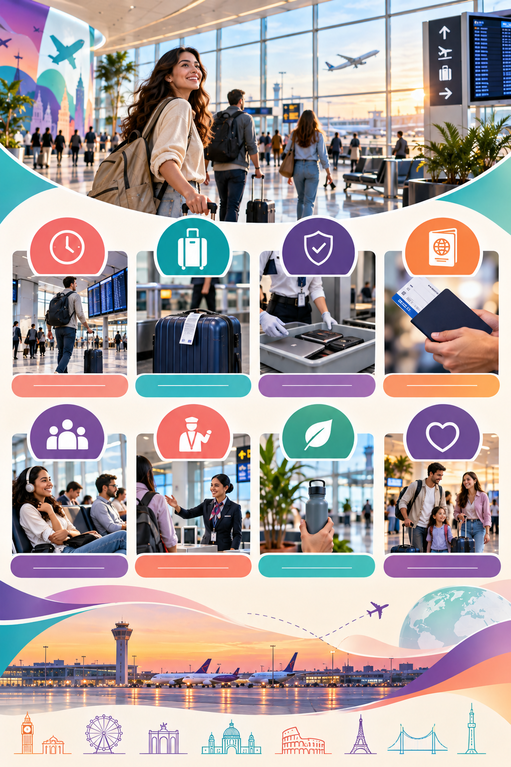
Create a professional passenger-awareness poster for a modern international airport using a fresh purple, teal, coral, orange, and soft cream colour palette, avoiding traditional blue-and-white airline branding. Show diverse passengers in a clean, modern airport terminal following responsible travel practices. Visually communicate airport safety, baggage awareness, security procedures, keeping travel documents safe, following airport instructions, arriving on time, and respecting fellow passengers through simple icons and visual storytelling. Use a clean infographic + realistic airport photography style, strong visual hierarchy, modern rounded shapes, subtle gradients, premium corporate design, and clear space for adding poster text. Landscape or portrait poster composition, high resolution, no airline logos, no brand names, no misleading safety instructions. Suitable for airport social-media campaigns, passenger education, awareness posters, and aviation-management presentations.

Create a premium airline loyalty-programme campaign visual with a fresh, sophisticated purple, teal, coral, gold, and soft cream colour palette, avoiding traditional blue-and-white airline branding. Show a stylish young traveller using a smartphone to view a digital loyalty membership, surrounded by subtle visual elements representing points, rewards, free upgrades, lounge access, priority boarding, travel benefits, and exclusive experiences. Include a modern airport terminal and aircraft subtly in the background. Use luxury travel advertising photography combined with clean digital UI-inspired graphics, elegant gradients, glowing reward icons, dynamic curved shapes, and strong visual hierarchy. Leave generous negative space for campaign headline, offer details, QR code, and call-to-action. Landscape 16:9 composition, high resolution, premium social-media advertising aesthetic. No airline logos, no real brand names, no fake statistics, and no excessive text.



Practical Task 1 — Run a Vague Prompt

Prompt to enter in both ChatGPT and Gemini:
Prepare a passenger announcement about the delay of Flight AV101.
Important: Do not provide any additional information such as the reason for delay, expected departure time, airport, or passenger instructions.

What students should observe
After running the same prompt in both tools, compare:
Observation | ChatGPT | Gemini
Announcement generated | Record output | Record output
Did it invent a reason for the delay? | Yes/No | Yes/No
Did it invent a new departure time? | Yes/No | Yes/No
Did it ask for missing information? | Yes/No | Yes/No
Tone of announcement | Record | Record
Any potentially misleading information? | Record | Record

Key learning: The prompt is intentionally vague. Students should identify whether the AI asks for clarification, makes assumptions, or produces unsupported details. This demonstrates why human verification and precise prompts are important in aviation communication.

Practical Task 2 — Identify Guesswork

Since the prompt provides no actual operational information, any specific details generated by either tool should be treated as assumptions and not used in a real passenger announcement.
Detail | Provided in Prompt? | ChatGPT Assumption | Gemini Assumption | Safe to Use?
Airline name | No | May assume or leave unspecified | May assume or leave unspecified | No
Route | No | May invent a departure/destination route | May invent a departure/destination route | No
Departure time | No | May provide or estimate a new time | May provide or estimate a new time | No
Delay duration | No | May invent a duration or use a generic statement | May invent a duration or use a generic statement | No
Reason for delay | No | May suggest a reason such as operational/weather issues | May suggest a reason such as operational/weather issues | No
Gate number | No | May invent or omit a gate number | May invent or omit a gate number | No
Compensation | No | May mention compensation without verified policy | May mention compensation without verified policy | No
Food/hotel arrangements | No | May suggest these arrangements | May suggest these arrangements | No
Contact details | No | May provide generic or invented contact information | May provide generic or invented contact information | No

Key Learning
If a detail is not provided or verified from an authoritative operational source, it must not be presented to passengers as a fact.
In aviation, information such as delay reason, revised departure time, gate, compensation, meals, and accommodation should be verified by authorized airline/airport personnel before communication.

Practical Task 3 — Improve the Prompt

Attention passengers travelling on Flight AV101 from Delhi to Mumbai.
We regret to inform you that your flight has been delayed by 60 minutes due to adverse weather conditions. The revised departure time is 5:30 PM. We apologize for the inconvenience and appreciate your patience and understanding. Passengers are requested to check the official airport display screens for further updates regarding the flight.
Thank you.

Practical Task 5 — Create a Safer Version

Prompt:
Prepare a professional airport announcement about the delay of Flight AV101. If any operational information is missing, insert [VERIFY WITH OFFICIAL SYSTEM] instead of guessing.

Expected safer output
Attention passengers travelling on Flight AV101.
We regret to inform you that your flight has been delayed. [VERIFY WITH OFFICIAL SYSTEM] Please check the official airport display screens for the latest information regarding your flight. We apologize for the inconvenience and appreciate your patience and understanding.
Thank you.

Observation
The output becomes safer because the AI is explicitly instructed not to invent missing operational information. Instead, it flags information that must be verified through an official system.
Key learning: In aviation, a prompt should include safeguards that prevent AI from turning missing information into unsupported facts.

Practical Task 6 — Short Reflection
- What information did the AI assume?
The AI could assume details such as the airline name, route, departure time, delay duration, reason for delay, gate number, compensation, or passenger arrangements when these were not provided.
- Did ChatGPT and Gemini make the same assumptions?
No. The two tools may produce different assumptions or handle missing information differently. Some details may be omitted by one tool but generated by the other.
- How did the specific prompt improve the output?
It clearly provided the required operational details and instructed the AI to use [VERIFY WITH OFFICIAL SYSTEM] rather than guessing when information was missing.
- Can a professional-looking response still be factually wrong?
Yes. A response can sound professional and convincing while containing incorrect or invented information. Therefore, professional wording does not guarantee factual accuracy.
- What must an aviation employee verify before using the announcement?
The employee should verify flight number, route, delay duration, reason for delay, revised departure time, gate information, and any passenger instructions against the airline/airport's official operational systems before broadcasting the announcement.

